**CNH Dealer Addresses:** CNH Dealer Addresses allows you to load the billing and shipping addresses that CNH has for them on file to CNH Connect (CSPS), which makes conducting billing and ordering simpler.

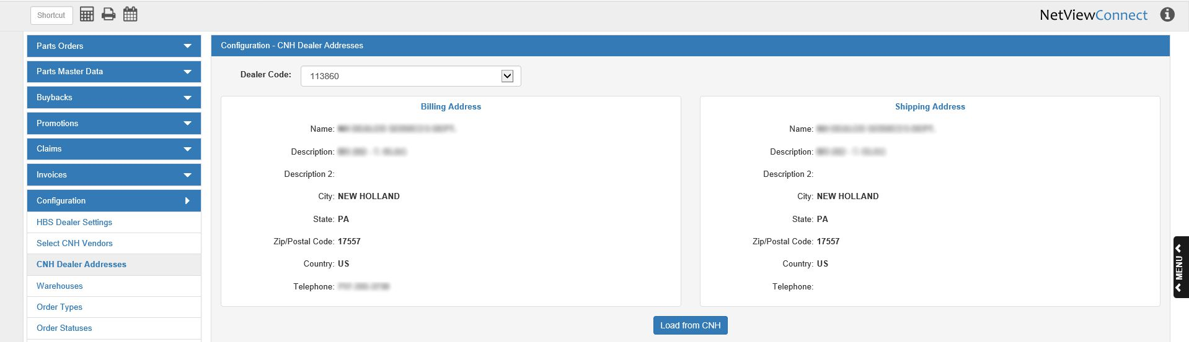

**Dealer Code:** Select the dealer code whose addresses you want to view from this drop-down menu. The addresses’ information will then fill in on the screen.

**Billing Address:** These fields show the billing address information for the chosen dealer code.

**Shipping Address:** These fields show the shipping address information for the chosen dealer code.

**Load from CNH:** When you first open CSPS, you will need to click this button to load the addresses from CNH. Otherwise, you will not be able to use them when making orders. After the button’s first use, you can click it at any point to load the most updated addresses. Also, any time you switch between dealer codes, the program will automatically load the most up-to-date addresses for that code from CNH.